# 

# **Assignment**

**GROUP B**

**DATABASE MANAGEMENT**

**Prof. Mehdi Pirahandeh**

**11.15.2022**

# **First step**

We firstly created db file and inserted all data we needed for final result

We deleted tables from existing db file to create new one and avoid errors.

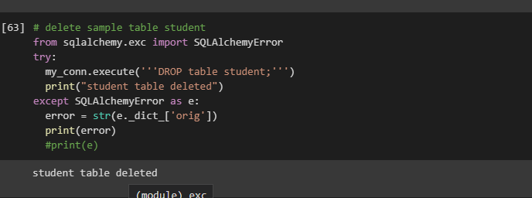

Then we created new one with new table and columns with settings

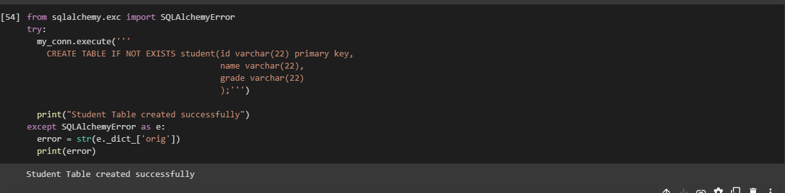

After that we inserted all data

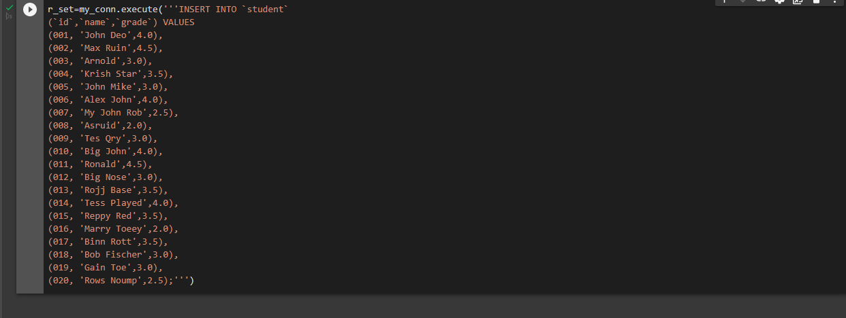

Then we downloaded file to check it in SQLite browser

# **Second step**

We inserted all codes as instructed in the class

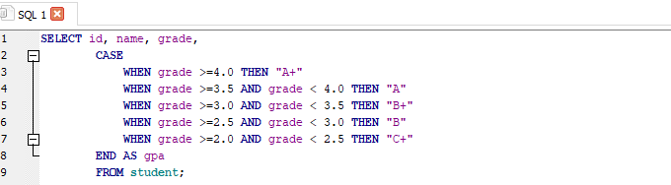

Then we run it and here is outcome

